**Nov 2015 SL P1**

**Section A**

1. Human interaction with the computer system includes a range of usability problems.
2. Define the term usability. [1]
3. Identify **two** methods that could be used to improve the accessibility of a computer

system. [2]

1. By making direct reference to the technologies used, explain how a virtual private network

(VPN) allows a travelling salesperson to connect securely to their company’s network. [4]

1. Construct a truth table for the following Boolean expression.  
     
    (A and B) nor C [3]
2. A small hotel buys a software package to manage their bookings.
3. Describe **two** types of documentation that should be provided with the software package. [4]
4. State **two** methods of delivering user training. [2]

1. A school uses a local area network (LAN) which connects several computers and a printer to

a server and allows access to the internet.

1. Define the term server. [1]
2. Identify the different clients in this network. [1]
3. (i) Identify **one** external threat to the security of the school’s computer system. [1]  
     
     
     
   (ii) State one way to protect the computer system from the threat identified in

part (c)(i). [1]

1. A sub-program all_even() accepts a positive integer N and outputs true if all digits of N

are even, otherwise it outputs false. For example, all_even(246) outputs true and

all_even(256) outputs false.

The following algorithm is constructed for the sub-program all_even(N).

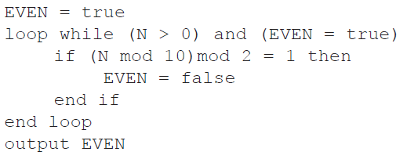

1. Explain why this algorithm does not obtain the correct result. [2]
2. Outline what should be changed in the algorithm to obtain the correct result. [3]

**Section B**

1. A hardware shop supplies a wide variety of bathroom equipment. There are 15 shop

assistants who serve customers, 3 office staff who handle the administration, and a manager.

A specialized company is asked to design and implement a new computer system for

the shop..

1. (i) Identify two different types of users of the system. [2]

(ii) Explain the role of users in the process of developing the new computer system. [3]

1. Describe why it is useful to produce more than one prototype of the new system. [2]
2. Outline **two** problems that may occur when transferring data from the old system to the

new system. [4]

The new system is implemented using parallel running.

1. (i) Outline what is meant by parallel running. [2]

(ii) Outline one reason for choosing parallel running as opposed to a direct changeover. [2]

1. 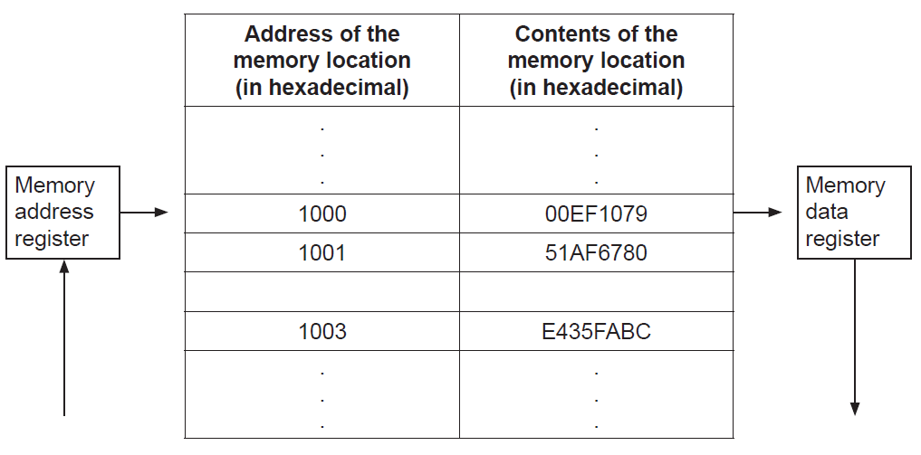The following diagram shows the structure of the random access memory (RAM).
2. Calculate the number of bits in each memory location. [1]
3. Calculate the number of bytes in each address. [1]
4. Outline the function of the:
5. memory address register [2]
6. memory data register. [2]
7. (i) Identify two functions of the operating system. [2]  
     
     
   (ii) State where the operating system is held when the computer is turned off. [1]

The machine instruction cycle refers to the retrieval of an instruction from the RAM, and  
 subsequently decoding, executing and storing the result.

1. (i) Construct a diagram to illustrate the structure of a central processing unit (CPU),

clearly showing the flow of data within the CPU. [4]

(ii) Identify the part of the CPU which performs decoding. [1]

(iii) Identify the part of the CPU which executes the instruction. [1]

1. A candy company manufactures 20 different kinds of candy, each identified by a product ID.

An array, Product_ID, is used to store the product IDs, and another array, Unit_Price, is

used to store the price per unit of each type of candy. The unit price of the product identified

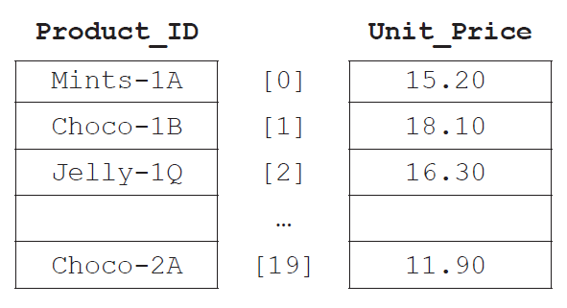by Product_ID[N] is equal to Unit_Price[N] for any index N.

1. State the price of the candy identified by Product_ID[2]. [1]
2. Explain the steps that would be needed in an algorithm to calculate the average unit

price. [3]

1. Construct the algorithm that will output the price of a candy after its product ID is

entered by the user. The algorithm should output an appropriate message if the

product ID entered does not appear in the array Product_ID. [6]

The company maintains two warehouses each of which stocks a selection of the 20 types of  
candy indicated above.  
  
The first warehouse stocks 15 items and their IDs are stored in an array, One. The second  
warehouse stocks 10 items and their IDs are stored in an array, Two.

All product IDs common to both warehouses will be placed in an array, Three.

1. (i) State the maximum number of common product IDs which can be placed   
    in Three. [1]  
     
     
   (ii) Construct the algorithm that will place all product IDs common to both  
    warehouses in Three. [4]